Point Pattern Analysis (Density_Based)

Afiq

2023-03-20

library(writexl)  
library(readxl)  
library(sf)

## Linking to GEOS 3.9.3, GDAL 3.5.2, PROJ 8.2.1; sf_use_s2() is TRUE

library(ggplot2)

## Warning: package 'ggplot2' was built under R version 4.2.3

library(rgdal)

## Loading required package: sp

## Please note that rgdal will be retired during 2023,  
## plan transition to sf/stars/terra functions using GDAL and PROJ  
## at your earliest convenience.  
## See https://r-spatial.org/r/2022/04/12/evolution.html and https://github.com/r-spatial/evolution  
## rgdal: version: 1.6-3, (SVN revision 1187)  
## Geospatial Data Abstraction Library extensions to R successfully loaded  
## Loaded GDAL runtime: GDAL 3.5.2, released 2022/09/02  
## Path to GDAL shared files: C:/Users/ACER/AppData/Local/R/win-library/4.2/rgdal/gdal  
## GDAL binary built with GEOS: TRUE   
## Loaded PROJ runtime: Rel. 8.2.1, January 1st, 2022, [PJ_VERSION: 821]  
## Path to PROJ shared files: C:/Users/ACER/AppData/Local/R/win-library/4.2/rgdal/proj  
## PROJ CDN enabled: FALSE  
## Linking to sp version:1.5-1  
## To mute warnings of possible GDAL/OSR exportToProj4() degradation,  
## use options("rgdal_show_exportToProj4_warnings"="none") before loading sp or rgdal.

library(here)

## here() starts at C:/Users/ACER/Documents/Spatial-Analysis-HFMD

library(tmap)  
library(dplyr)

## Warning: package 'dplyr' was built under R version 4.2.3

##   
## Attaching package: 'dplyr'

## The following objects are masked from 'package:stats':  
##   
## filter, lag

## The following objects are masked from 'package:base':  
##   
## intersect, setdiff, setequal, union

library(spatstat)

## Loading required package: spatstat.data

## Loading required package: spatstat.geom

## spatstat.geom 3.0-3

## Loading required package: spatstat.random

## spatstat.random 3.0-1

## Loading required package: spatstat.explore

## Loading required package: nlme

##   
## Attaching package: 'nlme'

## The following object is masked from 'package:dplyr':  
##   
## collapse

## spatstat.explore 3.0-5

## Loading required package: spatstat.model

## Loading required package: rpart

## spatstat.model 3.0-2

## Loading required package: spatstat.linnet

## spatstat.linnet 3.0-3

##   
## spatstat 3.0-2   
## For an introduction to spatstat, type 'beginner'

library(tidyverse)

## ── Attaching packages  
## ───────────────────────────────────────  
## tidyverse 1.3.2 ──

## ✔ tibble 3.2.1 ✔ purrr 1.0.1  
## ✔ tidyr 1.3.0 ✔ stringr 1.5.0  
## ✔ readr 2.1.3 ✔ forcats 0.5.2

## Warning: package 'tibble' was built under R version 4.2.3

## ── Conflicts ────────────────────────────────────────── tidyverse_conflicts() ──  
## ✖ nlme::collapse() masks dplyr::collapse()  
## ✖ dplyr::filter() masks stats::filter()  
## ✖ dplyr::lag() masks stats::lag()

library (RColorBrewer)

# Load HFMD Data

HFMD_overall <- read_excel( here("Density Based Analysis",  
 "HFMD_17_22.xlsx"))  
HFMD_overall <- st_as_sf(HFMD_overall,coords = c("X_LONGITUDE","X_LATITUDE"),   
 crs = 4326)  
HFMD_overall <- st_transform(HFMD_overall, 3168)  
Penang <- st_read(here("Penang",   
 "mukim2000_penang1.shp"))

## Reading layer `mukim2000_penang1' from data source   
## `C:\Users\ACER\Documents\Spatial-Analysis-HFMD\Penang\mukim2000_penang1.shp'   
## using driver `ESRI Shapefile'  
## Simple feature collection with 83 features and 4 fields  
## Geometry type: MULTIPOLYGON  
## Dimension: XY  
## Bounding box: xmin: 243501.5 ymin: 567201.1 xmax: 285076.2 ymax: 618503.2  
## CRS: NA

#View Data

st_crs(Penang)<-3168  
st_crs(Penang)

## Coordinate Reference System:  
## User input: EPSG:3168   
## wkt:  
## PROJCRS["Kertau (RSO) / RSO Malaya (m)",  
## BASEGEOGCRS["Kertau (RSO)",  
## DATUM["Kertau (RSO)",  
## ELLIPSOID["Everest 1830 (RSO 1969)",6377295.664,300.8017,  
## LENGTHUNIT["metre",1]]],  
## PRIMEM["Greenwich",0,  
## ANGLEUNIT["degree",0.0174532925199433]],  
## ID["EPSG",4751]],  
## CONVERSION["Rectified Skew Orthomorphic Malaya Grid (metres)",  
## METHOD["Hotine Oblique Mercator (variant A)",  
## ID["EPSG",9812]],  
## PARAMETER["Latitude of projection centre",4,  
## ANGLEUNIT["degree",0.0174532925199433],  
## ID["EPSG",8811]],  
## PARAMETER["Longitude of projection centre",102.25,  
## ANGLEUNIT["degree",0.0174532925199433],  
## ID["EPSG",8812]],  
## PARAMETER["Azimuth of initial line",323.0257905,  
## ANGLEUNIT["degree",0.0174532925199433],  
## ID["EPSG",8813]],  
## PARAMETER["Angle from Rectified to Skew Grid",323.130102361111,  
## ANGLEUNIT["degree",0.0174532925199433],  
## ID["EPSG",8814]],  
## PARAMETER["Scale factor on initial line",0.99984,  
## SCALEUNIT["unity",1],  
## ID["EPSG",8815]],  
## PARAMETER["False easting",804670.24,  
## LENGTHUNIT["metre",1],  
## ID["EPSG",8806]],  
## PARAMETER["False northing",0,  
## LENGTHUNIT["metre",1],  
## ID["EPSG",8807]]],  
## CS[Cartesian,2],  
## AXIS["(E)",east,  
## ORDER[1],  
## LENGTHUNIT["metre",1]],  
## AXIS["(N)",north,  
## ORDER[2],  
## LENGTHUNIT["metre",1]],  
## USAGE[  
## SCOPE["Engineering survey, topographic mapping."],  
## AREA["Malaysia - West Malaysia onshore."],  
## BBOX[1.21,99.59,6.72,104.6]],  
## ID["EPSG",3168]]

glimpse(HFMD_overall)

## Rows: 15,586  
## Columns: 12  
## $ CASE_ID <chr> "Case 1", "Case 2", "Case 3", "Case 4", "Case 5", "Case …  
## $ YEAR <dbl> 2018, 2018, 2018, 2018, 2018, 2018, 2018, 2019, 2019, 20…  
## $ MONTH <chr> "October", "August", "July", "July", "July", "November",…  
## $ WEEK <dbl> 44, 32, 27, 28, 28, 44, 38, 14, 3, 11, 12, 8, 2, 13, 11,…  
## $ AGE <dbl> 1, 1, 3, 1, 2, 5, 4, 4, 5, 2, 4, 4, 1, 1, 1, 3, 1, 5, 1,…  
## $ RACE <chr> "Cina", "Melayu", "Melayu", "Melayu", "Melayu", "Cina", …  
## $ GENDER <chr> "Lelaki", "Lelaki", "Perempuan", "Perempuan", "Perempuan…  
## $ DAERAH <chr> "Seberang PERAI TENGAH", "Seberang PERAI TENGAH", "Seber…  
## $ ADDRESS <chr> "47 JALAN BUDIMAN 2, TAMAN BUDIMAN BUKIT MERTAJAMPulau P…  
## $ X_ADDRESS <chr> "47 Jalan Budiman 2, Taman Budiman, Bukit Mertajam, Sebe…  
## $ within_Penang <dbl> 1, 1, 1, 1, 1, 1, 1, 1, 1, 1, 1, 1, 1, 1, 1, 1, 1, 1, 1,…  
## $ geometry <POINT [m]> POINT (277266.8 589310.9), POINT (271351.3 594495.…

# Plot HFMD points(2017-2022) in Penang Polygon

tm_shape(Penang)+tm_polygons("NAMMUK", title = "Subdistricts")+ tm_layout(main.title = "Pulau Pinang")+ tmap_options(max.categories = 51)+ tm_layout(legend.outside = TRUE)+ tm_compass(type = "4star", size = 2, position = c("left", "top"))

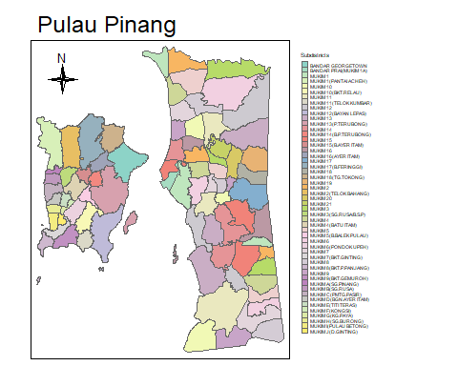

tm_shape(Penang)+ tm_polygons("NAMA_DP", title = "District")+ tm_shape(HFMD_overall) + tm_dots(size = 0.0,col = "black")+ tm_layout(legend.outside = TRUE)+ tm_compass(type = "4star", size = 2, position = c("left", "top"))+tm_layout(main.title = "HFMD Infection in Pulau Pinang")

## Warning in max(x, na.rm = TRUE): no non-missing arguments to max; returning -Inf

## Warning in max(symbol.size, na.rm = TRUE): no non-missing arguments to max;  
## returning -Inf

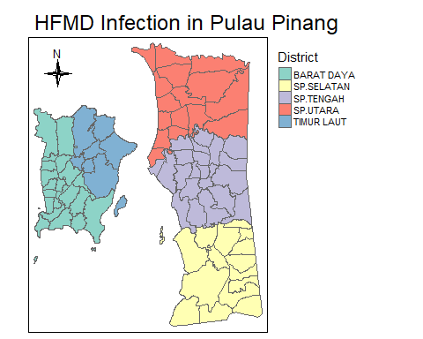

## Plot Yearly HFMD Cases in Pulau Pinang

tm_shape(Penang) +  
 tm_polygons("NAMA_DP",title = "DISTRICT") +   
 tm_shape(HFMD_overall) + tm_layout( legend.outside = TRUE) + tm_dots(col = "black", size = 0.03 ) +  
 tm_layout(main.title = "HFMD Infection in Pulau Pinang 2017-2022") + tm_facets("YEAR", nrow = 2, ncol = 3, as.layers = TRUE) + tm_compass(type = "4star", size = 2, position = c("left", "top"))

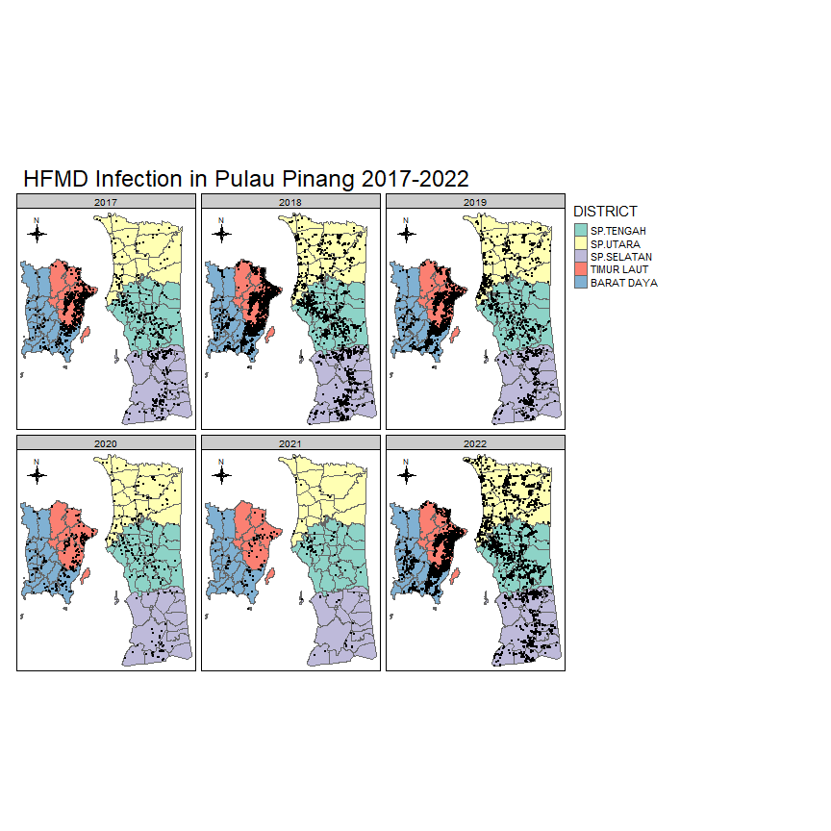

## Plot HFMD points(2017-2022) according to district

#Plot Case According to district  
ggplot(  
 data = HFMD_overall,  
 mapping = aes (  
 x = fct_rev(fct_infreq (DAERAH)))) +  
 geom_bar() +  
 coord_flip()+  
 theme_classic()+  
 labs(  
 x = "District",  
 y = "Number of Cases",  
 title = "HFMD Cases in Pulau Pinang"  
 )

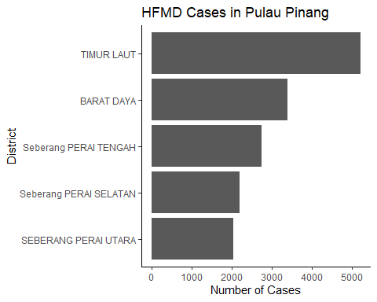

tm_shape(Penang[Penang$NAMA_DP == "TIMUR LAUT",])+tm_layout(main.title = "HFMD Infection in Timur Laut 2017-2022") +  
 tm_polygons("NAMMUK",title = "SUBDISTRICT") +  
 tm_shape(HFMD_overall[HFMD_overall$DAERAH == "TIMUR LAUT",])+tm_dots (col = "black")+tm_layout(legend.outside = TRUE) + tm_facets("YEAR", nrow = 2, ncol = 3, as.layers = TRUE)

## Legend labels were too wide. The labels have been resized to 0.54, 0.50, 0.55, 0.60, 0.58, 0.57, 0.53. Increase legend.width (argument of tm_layout) to make the legend wider and therefore the labels larger.

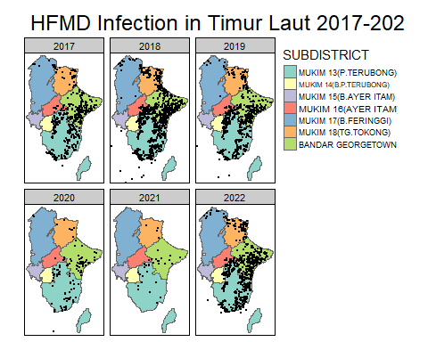

tm_shape(Penang[Penang$NAMA_DP == "BARAT DAYA",])+  
 tm_polygons("NAMMUK",title = "SUBDISTRICT")+tm_layout(main.title = "HFMD Infection in Barat Daya 2017-2022") +  
 tm_shape(HFMD_overall[HFMD_overall$DAERAH == "BARAT DAYA",])+tm_dots (col = "black")+tm_layout(legend.outside = TRUE) + tm_facets("YEAR", nrow = 2, ncol = 3, as.layers = TRUE)

## Some legend labels were too wide. These labels have been resized to 0.58, 0.51, 0.59, 0.53, 0.53, 0.51, 0.53, 0.51, 0.53, 0.59, 0.51, 0.53, 0.59, 0.49, 0.52. Increase legend.width (argument of tm_layout) to make the legend wider and therefore the labels larger.

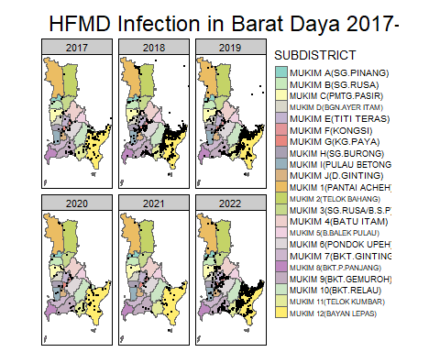

tm_shape(Penang[Penang$NAMA_DP == "SP.TENGAH",])+  
 tm_polygons("NAMMUK",title = "SUBDISTRICT")+tm_layout(main.title = "HFMD Infection in SP.Tengah 2017-2022") +  
 tm_shape(HFMD_overall[HFMD_overall$DAERAH == "Seberang PERAI TENGAH",])+tm_dots (col = "black")+tm_layout(legend.outside = TRUE) + tm_facets("YEAR", nrow = 2, ncol = 3, as.layers = TRUE)

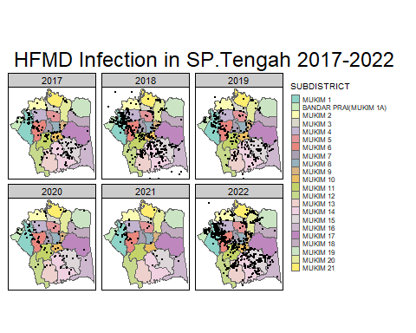

tm_shape(Penang[Penang$NAMA_DP == "SP.UTARA",])+  
 tm_polygons("NAMMUK",title = "SUBDISTRICT")+tm_layout(main.title = "HFMD Infection in SP.Utara 2017-2022") +  
 tm_shape(HFMD_overall[HFMD_overall$DAERAH == "SEBERANG PERAI UTARA",])+tm_dots (col = "black")+tm_layout(legend.outside = TRUE) + tm_facets("YEAR", nrow = 2, ncol = 3, as.layers = TRUE)

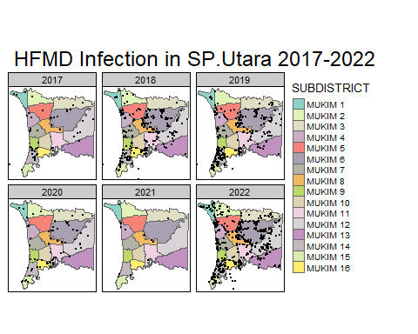

tm_shape(Penang[Penang$NAMA_DP == "SP.SELATAN",])+  
 tm_polygons("NAMMUK",title = "SUBDISTRICT")+ tm_layout(main.title = "HFMD Infection in SP.Selatan")+  
 tm_shape(HFMD_overall[HFMD_overall$DAERAH == "Seberang PERAI SELATAN",])+tm_dots (col = "black")+tm_layout(legend.outside = TRUE) + tm_facets("YEAR", nrow = 2, ncol = 3, as.layers = TRUE)

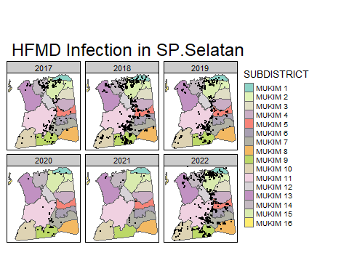

## Plot Monthly HFMD Cases in Pulau Pinang

### 1.Convert “MONTH” variable to factor with ordered levels

HFMD_overall$MONTH <- factor(HFMD_overall$MONTH,   
 levels = month.name,   
 ordered = TRUE)

#### Plotting monthly HFMD Map

tm_shape(Penang) +   
 tm_polygons("NAMA_DP", title = "DISTRICT") +   
 tm_layout(main.title = "Monthly HFMD Cases")+  
 tm_shape(HFMD_overall) +  
 tm_layout( legend.outside = TRUE) +   
 tm_dots(col = "black", size = 0.03 ) +   
 tm_facets("MONTH", "YEAR",nrow = 2, ncol = 6, as.layers = TRUE)

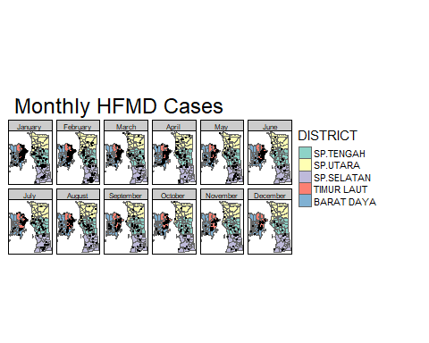

## ===========================

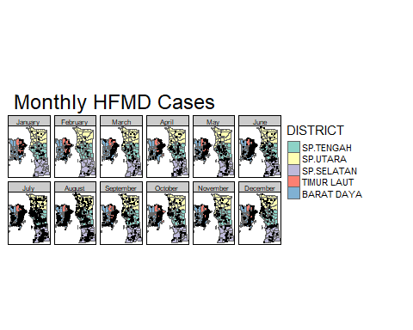

## =============

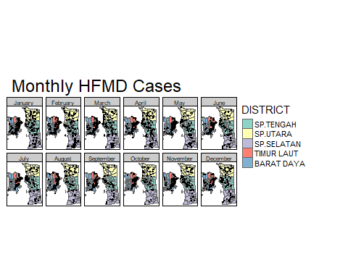

## =============

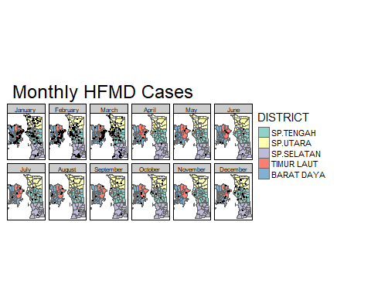

## ==============

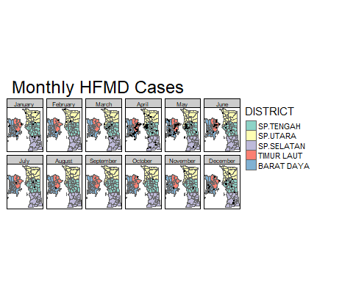

## =============

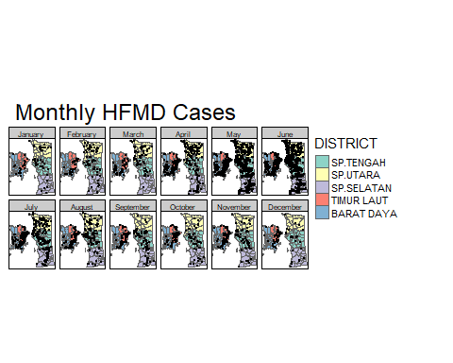

# Incidence of HFMD in Pulau Pinang

# 1.Prepare Data

# 2.count point in each Mukim

Overall_Coor <- HFMD_overall [,c('geometry','YEAR','DAERAH')]  
Overall_Coor <- na.omit(Overall_Coor)

intersection_overall <- st_intersection(x=Penang,y=Overall_Coor)

## Warning: attribute variables are assumed to be spatially constant throughout all  
## geometries

count_HFMD_Mukim_Overall <- intersection_overall %>% count (YEAR,NAMA_DP,NAMMUK,PENDUDUK)

# 3.Load population data

Gen_pop <- read_excel(here("Density Based Analysis",  
 "Gen_Pop.xlsx"))

# 4.calculate incidence

HFMD_Penang_Overall <- merge(count_HFMD_Mukim_Overall,Gen_pop, by = c("YEAR", "NAMA_DP","NAMMUK") , all=TRUE)  
Overall_Incidence <- HFMD_Penang_Overall %>% mutate(Incidence_1000 = (n/PENDUDUK_L)*1000)

# 5. Merge Penang and HFMD Incidence Data

HFMD_Penang_Overall_Incidence <- st_join(Penang, Overall_Incidence)  
glimpse(HFMD_Penang_Overall_Incidence)

## Rows: 443  
## Columns: 12  
## $ NAMA_NG <chr> "PULAU PINANG", "PULAU PINANG", "PULAU PINANG", "PULAU …  
## $ NAMA_DP.x <chr> "SP.TENGAH", "SP.TENGAH", "SP.TENGAH", "SP.TENGAH", "SP…  
## $ NAMMUK.x <chr> "MUKIM 1", "MUKIM 1", "MUKIM 1", "MUKIM 1", "MUKIM 1", …  
## $ PENDUDUK.x <dbl> 42653, 42653, 42653, 42653, 42653, 42653, 12644, 12644,…  
## $ YEAR <dbl> 2017, 2018, 2019, 2020, 2021, 2022, 2017, 2018, 2019, 2…  
## $ NAMA_DP.y <chr> "SP.TENGAH", "SP.TENGAH", "SP.TENGAH", "SP.TENGAH", "SP…  
## $ NAMMUK.y <chr> "MUKIM 1", "MUKIM 1", "MUKIM 1", "MUKIM 1", "MUKIM 1", …  
## $ PENDUDUK.y <dbl> 42653, 42653, 42653, 42653, 42653, 42653, 12644, 12644,…  
## $ n <int> 29, 128, 87, 26, 25, 194, 7, 22, 17, 5, 1, 41, 7, 13, 3…  
## $ PENDUDUK_L <dbl> 44300, 44100, 44000, 43800, 43800, 43800, 15900, 15900,…  
## $ Incidence_1000 <dbl> 0.6546275, 2.9024943, 1.9772727, 0.5936073, 0.5707763, …  
## $ geometry <MULTIPOLYGON [m]> MULTIPOLYGON (((269049.6 59..., MULTIPOLYG…

# 6.Plot HFMD Incidence in Pulau Pinang (Overall)

tm_shape(Penang) + tm_borders(alpha=.6) + tm_shape(HFMD_Penang_Overall_Incidence) + tm_polygons("Incidence_1000",style = "jenks", palette = brewer.pal(5, "YlOrRd"), range = c(0, 1000),title = "Incidence Per 1000") +tm_layout( legend.outside = TRUE) + tm_layout(main.title = "Incidence of HFMD In Pulau Pinang")+ tm_compass(type = "4star", size = 2, position = c("left", "top"))

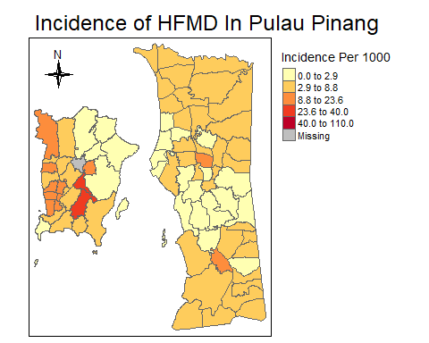 # 7.Plot Yearly Incidence Rate of HFMD in Pulau Pinang

tm_shape(Penang) + tm_borders(alpha=.6) + tm_shape(HFMD_Penang_Overall_Incidence) + tm_polygons("Incidence_1000",style = "jenks", title = "Per 1000 Population", palette = "Reds", range = c(0, 1000)) + tm_facets("YEAR", nrow = 2, ncol = 3, as.layers = TRUE) +tm_layout(main.title = "Incidence of HFMD in Pulau Pinang 2017-2022") +tm_compass(type = "4star", size = 2, position = c("left", "top"))

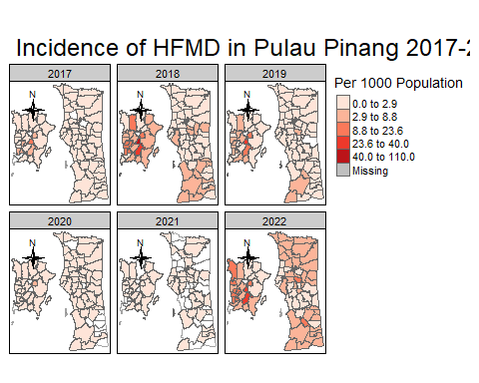

## ================================================================================

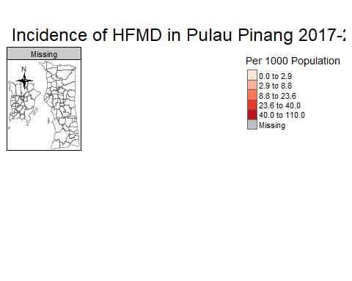 # 8. Yearly incidence according to district in Pulau Pinang # Timur Laut

tm_shape(Penang[Penang$NAMA_DP == "TIMUR LAUT", ])+ tm_borders(alpha=.6) +  
tm_shape(HFMD_Penang_Overall_Incidence[HFMD_Penang_Overall_Incidence$ NAMA_DP.x== "TIMUR LAUT",])+tm_polygons("Incidence_1000",style = "jenks", title = "(Incidence per 1000 Population)", palette = "Reds") + tm_facets("YEAR", ncol = 6, as.layers = TRUE)+tm_layout(title = "INCIDENCE OF HFMD IN TIMUR LAUT",title.size=1)+ tm_layout(legend.outside = TRUE)

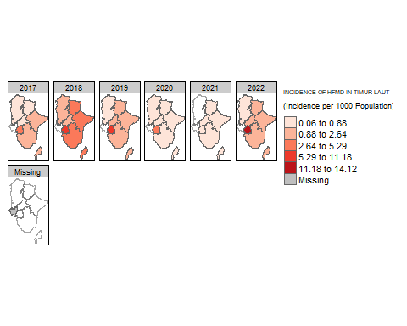 # Barat Daya

tm_shape(Penang[Penang$NAMA_DP == "BARAT DAYA", ])+ tm_borders(alpha=.6) +  
tm_shape(HFMD_Penang_Overall_Incidence[HFMD_Penang_Overall_Incidence$ NAMA_DP.x== "BARAT DAYA",])+tm_polygons("Incidence_1000",style = "jenks", title = "(Incidence per 1000 Population)", palette = "Reds") + tm_facets("YEAR", ncol = 6, as.layers = TRUE)+tm_layout(title = "INCIDENCE OF HFMD IN BARAT DAYA",title.size=1)+ tm_layout(legend.outside = TRUE)

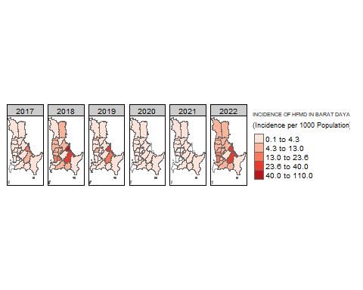 # SP Tengah

tm_shape(Penang[Penang$NAMA_DP == "SP.TENGAH", ])+ tm_borders(alpha=.6) +  
tm_shape(HFMD_Penang_Overall_Incidence[HFMD_Penang_Overall_Incidence$ NAMA_DP.x== "SP.TENGAH",])+tm_polygons("Incidence_1000",style = "jenks", title = "(Incidence per 1000 Population)", palette = "Reds") + tm_facets("YEAR", ncol = 6, as.layers = TRUE)+tm_layout(title = "INCIDENCE OF HFMD IN SP.PERAI TENGAH",title.size=1)+ tm_layout(legend.outside = TRUE)

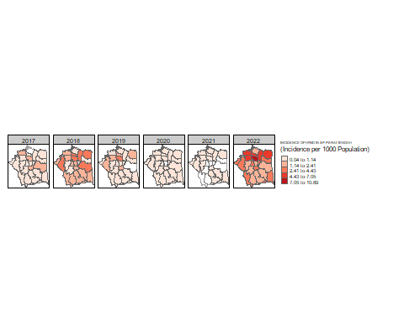 # SP Utara

tm_shape(Penang[Penang$NAMA_DP == "SP.UTARA", ])+ tm_borders(alpha=.6) +  
tm_shape(HFMD_Penang_Overall_Incidence[HFMD_Penang_Overall_Incidence$ NAMA_DP.x== "SP.UTARA",])+tm_polygons("Incidence_1000",style = "jenks", title = "(Incidence per 1000 Population)", palette = "Reds") + tm_facets("YEAR", ncol = 6, as.layers = TRUE)+tm_layout(title = "INCIDENCE OF HFMD IN SP.UTARA",title.size=1)+ tm_layout(legend.outside = TRUE)

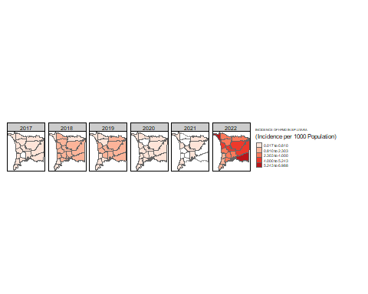 # SP Selatan

tm_shape(Penang[Penang$NAMA_DP == "SP.SELATAN", ])+ tm_borders(alpha=.6) +  
tm_shape(HFMD_Penang_Overall_Incidence[HFMD_Penang_Overall_Incidence$ NAMA_DP.x== "SP.SELATAN",])+tm_polygons("Incidence_1000",style = "jenks", title = "(Incidence per 1000 Population)", palette = "Reds") + tm_facets("YEAR", ncol = 6, as.layers = TRUE)+tm_layout(title = "INCIDENCE OF HFMD IN SP.SELATAN",title.size=1)+ tm_layout(legend.outside = TRUE)

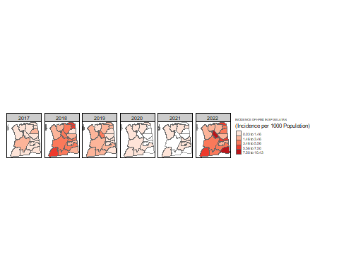 # Density Based Analysis using Kernel Density Estimates (KDE) # Rescale and load point feature into Penang.owin #Move coordinate to first column

HFMD_overall <- HFMD_overall[, c("geometry", names(HFMD_overall)[-which(names(HFMD_overall) == "geometry")])]

#Create owin data for Penang

Penang.owin <- as.owin(Penang)  
Penang.owin.km <- rescale(Penang.owin, 1000)

#Load point feature shapefile into Penang.owin

HFMD_overall.ppp <- as.ppp(HFMD_overall)

## Warning in as.ppp.sf(HFMD_overall): only first attribute column is used for  
## marks

marks(HFMD_overall.ppp) <- NULL  
HFMD_overall.ppp <- rescale(HFMD_overall.ppp, 1000,"km")  
Window(HFMD_overall.ppp) <- Penang.owin.km

#Kernel Density Estimates (KDE) Pulau Pinang

HFMD_overall.density <- density(HFMD_overall.ppp, sigma=1)   
class(HFMD_overall.density)

## [1] "im"

#Rasterize the KDE image using package raster

library(raster)

##   
## Attaching package: 'raster'

## The following object is masked from 'package:nlme':  
##   
## getData

## The following object is masked from 'package:dplyr':  
##   
## select

library(viridis)

## Loading required package: viridisLite

library(leaflet)

HFMD_overall.density.raster <- raster(HFMD_overall.density)

#Change the extent of the rasterlayer #1.define intended extend objects using Kelantan polygon

xmin= 243501.5   
xmax= 285076.2  
ymin= 567201.1   
ymax= 618503.2

#2.grab the cols and rows for the raster using @ncols and @nrows

HFMD_overall.density.raster @ncols

## [1] 128

HFMD_overall.density.raster @nrows

## [1] 128

#3.create a raster extend class

rasExt <- extent(xmin,xmax,ymin,ymax)  
rasExt

## class : Extent   
## xmin : 243501.5   
## xmax : 285076.2   
## ymin : 567201.1   
## ymax : 618503.2

#4.apply the extent to our KDE raster

HFMD_overall.density.raster@extent <- rasExt

crs(HFMD_overall.density.raster) <- 3168

## Plot Intensity of HFMD in Pulau Pinang

tm_shape(Penang) +  
 tm_borders(alpha=.6) +  
 tm_shape(HFMD_overall.density.raster) +   
 tm_raster(style = "quantile", n = 7 , palette = viridis(7, direction = 1), alpha = .4, title = "KDE Values") + tm_layout(main.title = "Spatial Intensity of HFMD in Pulau Pinang",title.size=1)+  
 tm_layout(legend.outside = TRUE)+ tm_compass(type = "4star", size = 2, position = c("left", "top"))

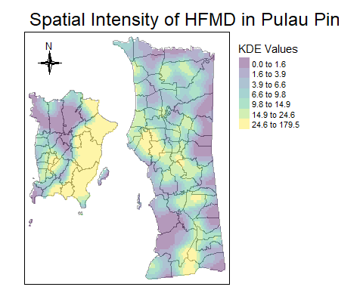 ## KDE intensity by YEAR #Convert “YEAR” variable to factor with ordered levels

HFMD_overall$YEAR <- factor(HFMD_overall$YEAR,   
 ordered = TRUE)

#Plot Case vs YEAR

counts <- table(HFMD_overall$YEAR)  
barplot(counts, main = "HFMD Infections", xlab = "Year",  
 ylab = "Number of Cases", cex.axis = 1, cex.lab = 1, cex.names = 0.7, ylim = c(0, 6500))  
text(x = 1:length(counts), y = counts, labels = counts, pos = 3, cex = 0.8)

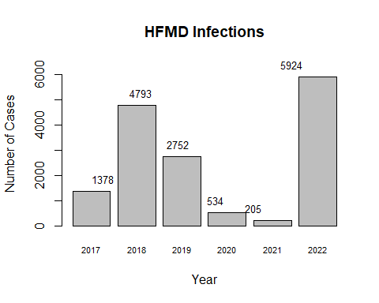 #KDE density for each year

Coor_Year <- HFMD_overall[,c(1,3,4)]  
Coor_Year <- na.omit(Coor_Year )

#Specified coordinate for male and female

Y2017_coor <- subset(Coor_Year, YEAR=='2017')   
Y2018_coor <- subset(Coor_Year, YEAR=='2018')   
Y2019_coor <- subset(Coor_Year, YEAR=='2019')   
Y2020_coor <- subset(Coor_Year, YEAR=='2020')   
Y2021_coor <- subset(Coor_Year, YEAR=='2021')   
Y2022_coor <- subset(Coor_Year, YEAR=='2022')

#Load a point feature shapefile into Penang.owin

Y2017_coor.ppp <- as.ppp(Y2017_coor)

## Warning in as.ppp.sf(Y2017_coor): only first attribute column is used for marks

marks(Y2017_coor.ppp ) <- NULL  
Y2017_coor.ppp <- rescale(Y2017_coor.ppp , 1000,"km")  
Window(Y2017_coor.ppp ) <- Penang.owin.km  
Y2018_coor.ppp <- as.ppp(Y2018_coor)

## Warning in as.ppp.sf(Y2018_coor): only first attribute column is used for marks

marks(Y2018_coor.ppp ) <- NULL  
Y2018_coor.ppp <- rescale(Y2018_coor.ppp , 1000,"km")  
Window(Y2018_coor.ppp ) <- Penang.owin.km  
Y2019_coor.ppp <- as.ppp(Y2019_coor)

## Warning in as.ppp.sf(Y2019_coor): only first attribute column is used for marks

marks(Y2019_coor.ppp ) <- NULL  
Y2019_coor.ppp <- rescale(Y2019_coor.ppp , 1000,"km")  
Window(Y2019_coor.ppp ) <- Penang.owin.km  
Y2020_coor.ppp <- as.ppp(Y2020_coor)

## Warning in as.ppp.sf(Y2020_coor): only first attribute column is used for marks

marks(Y2017_coor.ppp ) <- NULL  
Y2020_coor.ppp <- rescale(Y2020_coor.ppp , 1000,"km")  
Window(Y2020_coor.ppp ) <- Penang.owin.km  
Y2021_coor.ppp <- as.ppp(Y2021_coor)

## Warning in as.ppp.sf(Y2021_coor): only first attribute column is used for marks

marks(Y2021_coor.ppp ) <- NULL  
Y2021_coor.ppp <- rescale(Y2021_coor.ppp , 1000,"km")  
Window(Y2021_coor.ppp ) <- Penang.owin.km  
Y2022_coor.ppp <- as.ppp(Y2022_coor)

## Warning in as.ppp.sf(Y2022_coor): only first attribute column is used for marks

marks(Y2022_coor.ppp ) <- NULL  
Y2022_coor.ppp <- rescale(Y2022_coor.ppp , 1000,"km")  
Window(Y2022_coor.ppp ) <- Penang.owin.km

#Create Density function for gender (bandwith 2KM)

Y2017.coor.density<- density(Y2017_coor.ppp, sigma=2)   
Y2018.coor.density<- density(Y2018_coor.ppp, sigma=2)   
Y2019.coor.density<- density(Y2019_coor.ppp, sigma=2)   
Y2020.coor.density<- density(Y2020_coor.ppp, sigma=2)   
Y2021.coor.density<- density(Y2021_coor.ppp, sigma=2)   
Y2022.coor.density<- density(Y2022_coor.ppp, sigma=2)

#Plot KDE for Yearly Case

plot(Y2017.coor.density, main = "2017", las = 1)  
contour(Y2017.coor.density, add = TRUE)

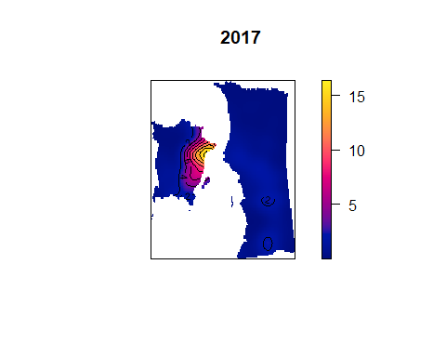

plot(Y2018.coor.density, main = "2018", las = 1)  
contour(Y2018.coor.density, add = TRUE)

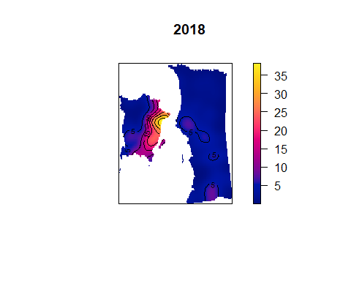

plot(Y2019.coor.density, main = "2019", las = 1)  
contour(Y2019.coor.density, add = TRUE)

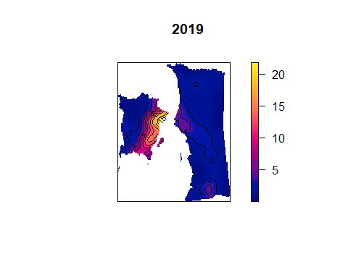

plot(Y2020.coor.density, main = "2020", las = 1)  
contour(Y2020.coor.density, add = TRUE)

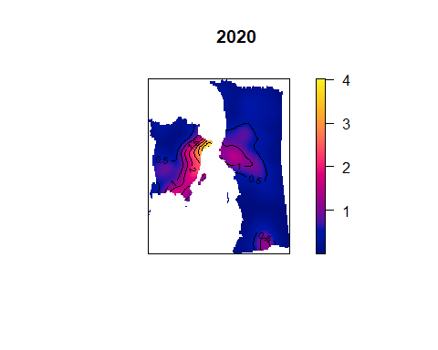

plot(Y2021.coor.density, main = "2021", las = 1)  
contour(Y2021.coor.density, add = TRUE)

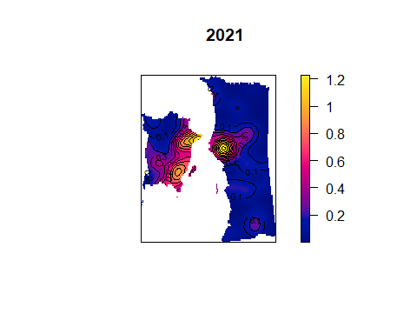

plot(Y2022.coor.density, main = "2022", las = 1)  
contour(Y2022.coor.density, add = TRUE)

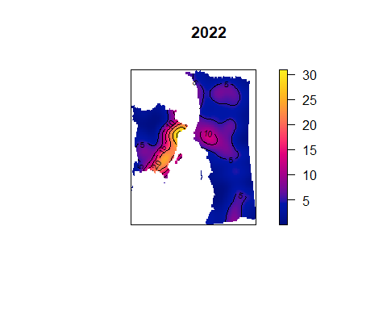

#rasterize KDE image  
Y2017.coor.density.raster <- raster(Y2017.coor.density)  
Y2018.coor.density.raster <- raster(Y2018.coor.density)  
Y2019.coor.density.raster <- raster(Y2019.coor.density)  
Y2020.coor.density.raster <- raster(Y2020.coor.density)  
Y2021.coor.density.raster <- raster(Y2021.coor.density)  
Y2022.coor.density.raster <- raster(Y2022.coor.density)

#apply extend to KDE raster  
Y2017.coor.density.raster@extent <- rasExt  
Y2018.coor.density.raster@extent <- rasExt  
Y2019.coor.density.raster@extent <- rasExt  
Y2020.coor.density.raster@extent <- rasExt  
Y2021.coor.density.raster@extent <- rasExt  
Y2022.coor.density.raster@extent <- rasExt

# transform coordinate  
crs (Y2017.coor.density.raster)<- 3168  
crs (Y2018.coor.density.raster)<- 3168  
crs (Y2019.coor.density.raster)<- 3168  
crs (Y2020.coor.density.raster)<- 3168  
crs (Y2021.coor.density.raster)<- 3168  
crs (Y2022.coor.density.raster)<- 3168

# Plot intensity map  
tm_shape(Penang) +  
 tm_borders(alpha=.6) +  
 tm_shape(Y2017.coor.density.raster) +   
 tm_raster(style = "quantile", n = 3 , palette = viridis(5, direction = 1), alpha = .4, title = "Cases per KM square") + tm_layout(main.title = "Spatial Intensity of HFMD 2017",title.size=1)+  
 tm_layout(legend.outside = TRUE)+ tm_compass(type = "4star", size = 2, position = c("left", "top"))

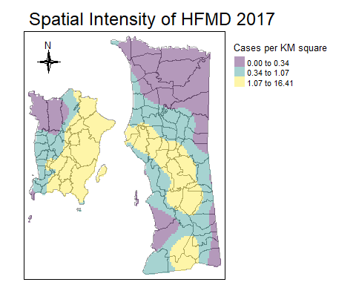

tm_shape(Penang) +  
 tm_borders(alpha=.6) +  
 tm_shape(Y2018.coor.density.raster) +   
 tm_raster(style = "quantile", n = 3 , palette = viridis(5, direction = 1), alpha = .4, title = "Cases per KM square") + tm_layout(main.title = "Spatial Intensity of HFMD 2018",title.size=1)+  
 tm_layout(legend.outside = TRUE)+ tm_compass(type = "4star", size = 2, position = c("left", "top"))

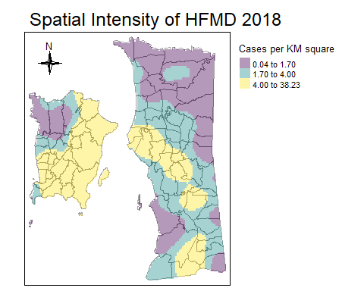

tm_shape(Penang) +  
 tm_borders(alpha=.6) +  
 tm_shape(Y2019.coor.density.raster) +   
 tm_raster(style = "quantile", n = 3 , palette = viridis(5, direction = 1), alpha = .4, title = "Cases per KM square") + tm_layout(main.title = "Spatial Intensity of HFMD 2019",title.size=1)+  
 tm_layout(legend.outside = TRUE)+ tm_compass(type = "4star", size = 2, position = c("left", "top"))

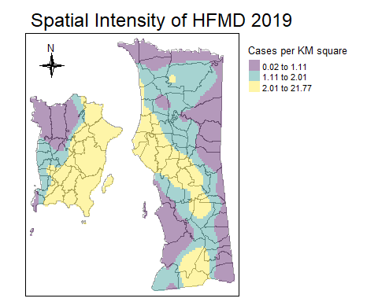

tm_shape(Penang) +  
 tm_borders(alpha=.6) +  
 tm_shape(Y2020.coor.density.raster) +   
 tm_raster(style = "quantile", n = 3 , palette = viridis(5, direction = 1), alpha = .4, title = "Cases per KM square") + tm_layout(main.title = "Spatial Intensity of HFMD 2020",title.size=1)+  
 tm_layout(legend.outside = TRUE)+ tm_compass(type = "4star", size = 2, position = c("left", "top"))

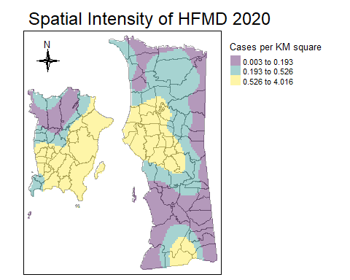

tm_shape(Penang) +  
 tm_borders(alpha=.6) +  
 tm_shape(Y2021.coor.density.raster) +   
 tm_raster(style = "quantile", n = 3 , palette = viridis(5, direction = 1), alpha = .4, title = "Cases per KM square") + tm_layout(main.title = "Spatial Intensity of HFMD 2021",title.size=1)+  
 tm_layout(legend.outside = TRUE)+ tm_compass(type = "4star", size = 2, position = c("left", "top"))

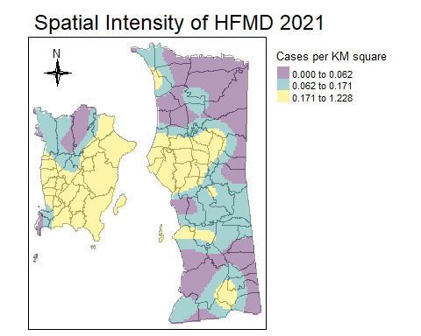

tm_shape(Penang) +  
 tm_borders(alpha=.6) +  
 tm_shape(Y2022.coor.density.raster) +   
 tm_raster(style = "quantile", n = 3 , palette = viridis(7, direction = 1), alpha = .4, title = "Cases per KM square") + tm_layout(main.title = "Spatial Intensity of HFMD 2022",title.size=1)+  
 tm_layout(legend.outside = TRUE)+ tm_compass(type = "4star", size = 2, position = c("left", "top"))

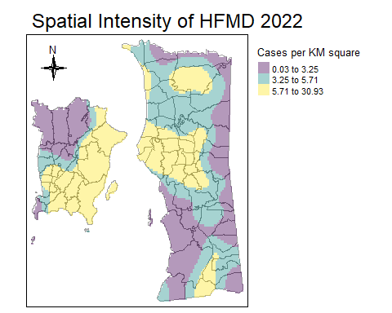

tm_shape(Penang) +  
 tm_borders(alpha= 1) +  
 tm_shape(Y2017.coor.density.raster) +   
 tm_raster(style = "cont", n = 7 , palette = "inferno", alpha = .7, title = "KDE") + tm_layout(main.title = "Spatial Intensity of HFMD 2017",title.size=1)+  
 tm_layout(legend.outside = TRUE)+ tm_compass(type = "4star", size = 2, position = c("left", "top"))

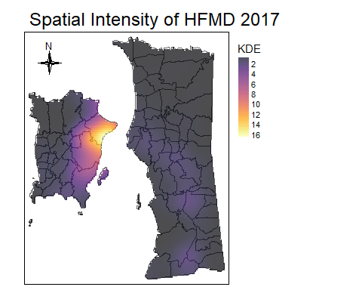

tm_shape(Penang) +  
 tm_borders(alpha= 1) +  
 tm_shape(Y2018.coor.density.raster) +   
 tm_raster(style = "cont", n = 7 , palette = "inferno", alpha = .7, title = "KDE") + tm_layout(main.title = "Spatial Intensity of HFMD 2018",title.size=1)+  
 tm_layout(legend.outside = TRUE)+ tm_compass(type = "4star", size = 2, position = c("left", "top"))

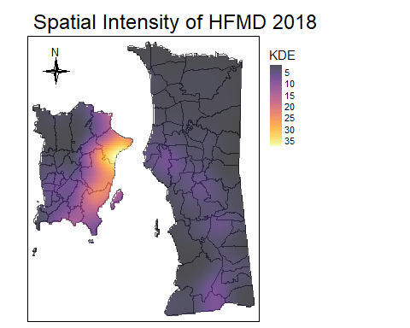

tm_shape(Penang) +  
 tm_borders(alpha= 1) +  
 tm_shape(Y2019.coor.density.raster) +   
 tm_raster(style = "cont", n = 7 , palette = "inferno", alpha = .7, title = "KDE") + tm_layout(main.title = "Spatial Intensity of HFMD 2019",title.size=1)+  
 tm_layout(legend.outside = TRUE)+ tm_compass(type = "4star", size = 2, position = c("left", "top"))

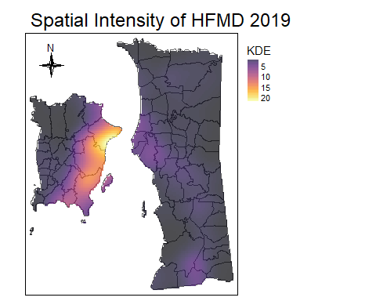

tm_shape(Penang) +  
 tm_borders(alpha= 1) +  
 tm_shape(Y2020.coor.density.raster) +   
 tm_raster(style = "cont", n = 7 , palette = "inferno", alpha = .7, title = "KDE") + tm_layout(main.title = "Spatial Intensity of HFMD 2020",title.size=1)+  
 tm_layout(legend.outside = TRUE)+ tm_compass(type = "4star", size = 2, position = c("left", "top"))

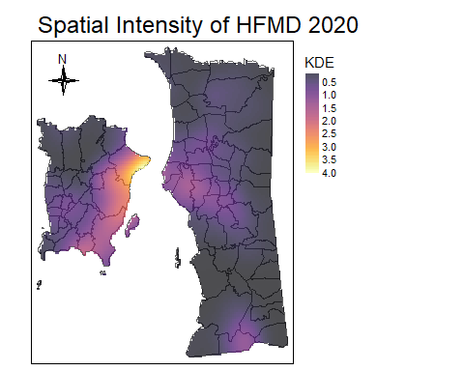

tm_shape(Penang) +  
 tm_borders(alpha= 1) +  
 tm_shape(Y2021.coor.density.raster) +   
 tm_raster(style = "cont", n = 7 , palette = "inferno", alpha = .7, title = "KDE") + tm_layout(main.title = "Spatial Intensity of HFMD 2021",title.size=1)+  
 tm_layout(legend.outside = TRUE)+ tm_compass(type = "4star", size = 2, position = c("left", "top"))

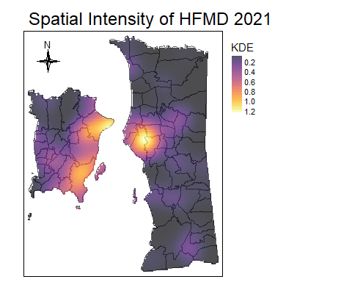

tm_shape(Penang) +  
 tm_borders(alpha=1) +  
 tm_shape(Y2022.coor.density.raster) +   
 tm_raster(style = "cont", n = 7 , palette = "inferno", alpha = .7, title = "KDE") + tm_layout(main.title = "Spatial Intensity of HFMD 2022",title.size=1)+  
 tm_layout(legend.outside = TRUE)+ tm_compass(type = "4star", size = 2, position = c("left", "top"))

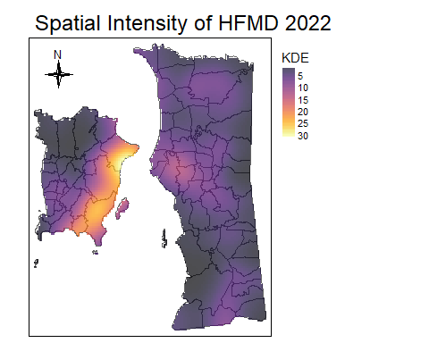

tm_shape(Penang) +  
 tm_borders(alpha=1) +  
 tm_shape(Y2017.coor.density.raster) +   
 tm_raster(style = "fisher", n = 5 , palette = "inferno", alpha = .7, title = "KDE") + tm_layout(main.title = "2017",title.size=1)+  
 tm_layout(legend.outside = TRUE)+ tm_compass(type = "4star", size = 2, position = c("left", "top"))

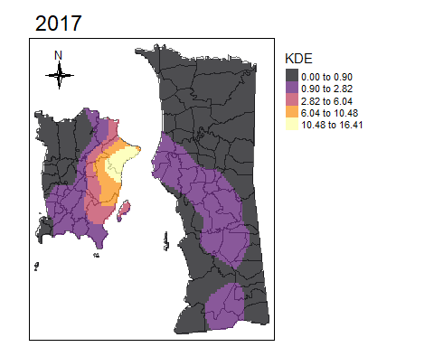

tm_shape(Penang) +  
 tm_borders(alpha=1) +  
 tm_shape(Y2018.coor.density.raster) +   
 tm_raster(style = "fisher", n = 5 , palette = "inferno", alpha = .7, title = "KDE") + tm_layout(main.title = "2018",title.size=1)+  
 tm_layout(legend.outside = TRUE)+ tm_compass(type = "4star", size = 2, position = c("left", "top"))

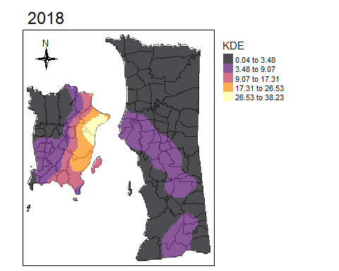

tm_shape(Penang) +  
 tm_borders(alpha=1) +  
 tm_shape(Y2019.coor.density.raster) +   
 tm_raster(style = "fisher", n = 5 , palette = "inferno", alpha = .7, title = "KDE") + tm_layout(main.title = "2019",title.size=1)+  
 tm_layout(legend.outside = TRUE)+ tm_compass(type = "4star", size = 2, position = c("left", "top"))

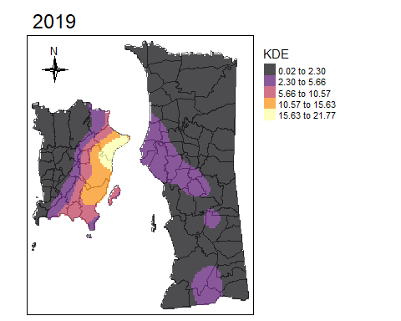

tm_shape(Penang) +  
 tm_borders(alpha=1) +  
 tm_shape(Y2020.coor.density.raster) +   
 tm_raster(style = "fisher", n = 5 , palette = "inferno", alpha = .7, title = "KDE") + tm_layout(main.title = "2020",title.size=1)+  
 tm_layout(legend.outside = TRUE)+ tm_compass(type = "4star", size = 2, position = c("left", "top"))

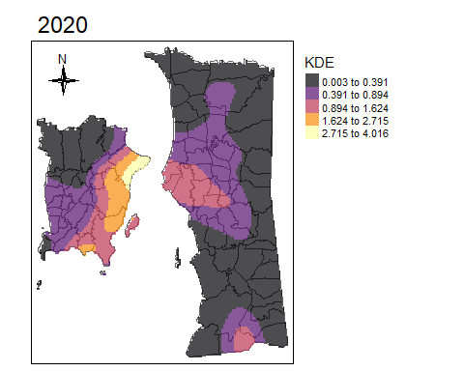

tm_shape(Penang) +  
 tm_borders(alpha=1) +  
 tm_shape(Y2021.coor.density.raster) +   
 tm_raster(style = "fisher", n = 5 , palette = "inferno", alpha = .7, title = "KDE") + tm_layout(main.title = "2021",title.size=1)+  
 tm_layout(legend.outside = TRUE)+ tm_compass(type = "4star", size = 2, position = c("left", "top"))

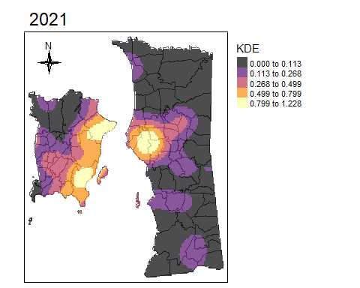

tm_shape(Penang) +  
 tm_borders(alpha=1) +  
 tm_shape(Y2022.coor.density.raster) +   
 tm_raster(style = "fisher", n = 5 , palette = "inferno", alpha = .7, title = "KDE") + tm_layout(main.title = "2022",title.size=1)+  
 tm_layout(legend.outside = TRUE)+ tm_compass(type = "4star", size = 2, position = c("left", "top"))

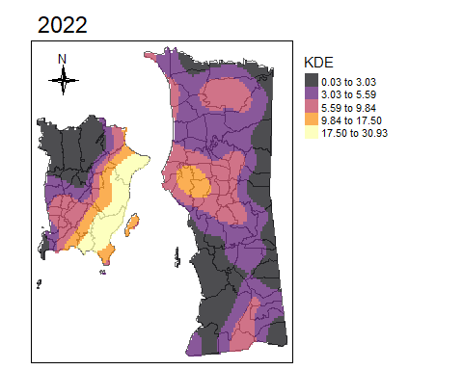

#KDE intensity by Gender ## Select Gender and Coordinate from data

Coor_Gender <- HFMD_overall[,c(1,8)]  
Coor_Gender <- na.omit(Coor_Gender)

#Specified coordinate for male and female

Male.coor <- subset(Coor_Gender, GENDER=='Lelaki')   
Female.coor <- subset(Coor_Gender, GENDER=='Perempuan')

#Load a point feature shapefile into Penang.owin

Male.coor.ppp <- as.ppp(Male.coor)  
marks(Male.coor.ppp ) <- NULL  
Male.coor.ppp <- rescale(Male.coor.ppp , 1000,"km")  
Window(Male.coor.ppp ) <- Penang.owin.km  
Female.coor.ppp <- as.ppp(Female.coor)  
marks(Female.coor.ppp ) <- NULL  
Female.coor.ppp <- rescale(Female.coor.ppp , 1000,"km")  
Window(Female.coor.ppp ) <- Penang.owin.km

#Create Density function for gender

Male.coor.density<- density(Male.coor.ppp , sigma=2)   
Female.coor.density <- density(Female.coor.ppp , sigma=2)

#Plot KDE for gender

par(mfrow=c(1,2))  
plot(Male.coor.density, main = "Male", las = 1)  
contour(Male.coor.density, add = TRUE)  
plot(Female.coor.density, main = "Female", las = 1)  
contour(Female.coor.density, add = TRUE)

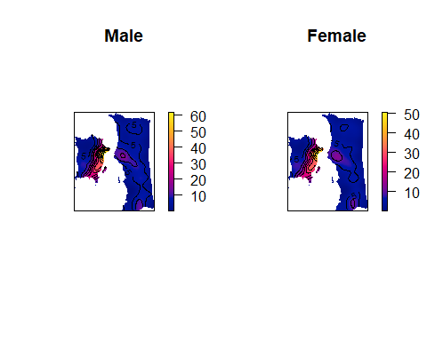 #KDE intensity by Age Group #Categorise age of the cases

HFMD_overall ["age_group"] = cut (HFMD_overall$AGE, c (0,5,10,Inf),c("0-4","5-10",">10"), include.lowest = TRUE)

#Plot Case vs Age Group

counts <- table(HFMD_overall$age_group)  
barplot(counts, main = "HFMD Infections", xlab = "Age Group",  
 ylab = "Number of Cases", cex.axis = 1, cex.lab = 1, cex.names = 0.7, ylim = c(0, 14000))  
text(x = 1:length(counts), y = counts, labels = counts, pos = 3, cex = 0.8)

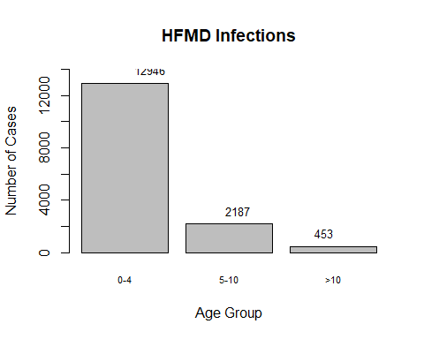 #KDE density for each age group

Coor_Age <- HFMD_overall[,c(1,13)]  
Coor_Age <- na.omit(Coor_Age )

#Specified coordinate for each age group

Coor_Age_1 <- subset(Coor_Age, age_group =='0-4')   
Coor_Age_2 <- subset(Coor_Age, age_group =='5-10')   
Coor_Age_3 <- subset(Coor_Age, age_group =='>10')

#Load a point feature shapefile into Penang.owin

Coor_Age_1.ppp <- as.ppp(Coor_Age_1)  
marks(Coor_Age_1.ppp ) <- NULL  
Coor_Age_1.ppp <- rescale(Coor_Age_1.ppp , 1000,"km")  
Window(Coor_Age_1.ppp ) <- Penang.owin.km  
Coor_Age_2.ppp <- as.ppp(Coor_Age_2)  
marks(Coor_Age_2.ppp ) <- NULL  
Coor_Age_2.ppp <- rescale(Coor_Age_2.ppp , 1000,"km")  
Window(Coor_Age_2.ppp ) <- Penang.owin.km  
Coor_Age_3.ppp <- as.ppp(Coor_Age_3)  
marks(Coor_Age_3.ppp ) <- NULL  
Coor_Age_3.ppp <- rescale(Coor_Age_3.ppp , 1000,"km")  
Window(Coor_Age_3.ppp ) <- Penang.owin.km

#Create Density function for each age group

Coor_Age_1.density<- density(Coor_Age_1.ppp, sigma=2)   
Coor_Age_2.density<- density(Coor_Age_2.ppp, sigma=2)   
Coor_Age_3.density<- density(Coor_Age_3.ppp, sigma=2)

#Plot KDE for each age group

par(mfrow=c(1,3))  
plot(Coor_Age_1.density, main = "0-4", las = 1)  
contour(Coor_Age_1.density, add = TRUE)  
plot(Coor_Age_2.density, main = "5-10", las = 1)  
contour(Coor_Age_2.density, add = TRUE)  
plot(Coor_Age_3.density, main = ">10", las = 1)  
contour(Coor_Age_3.density, add = TRUE)

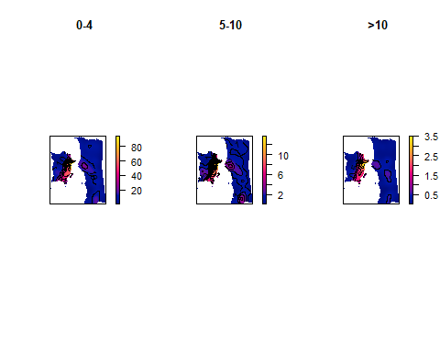 #Plot Case vs Month

counts <- table(HFMD_overall$MONTH)  
barplot(counts, main = "HFMD Infections", xlab = "MONTH",  
 ylab = "Number of Cases", cex.axis = 1, cex.lab = 1, cex.names = 0.7, ylim = c(0, 3000))

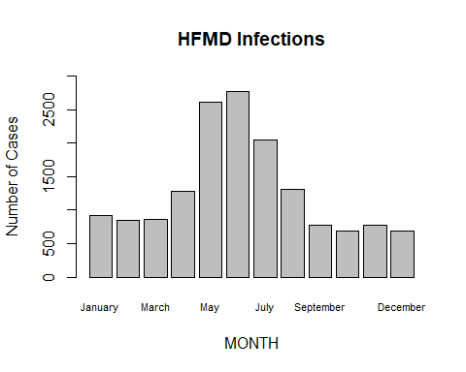

# Test for clustering using Gest Test

# Use split to calculate the G-function   
g_pattern_2017 <- Gest(Y2017_coor.ppp, correction = "none")  
g_pattern_2018 <- Gest(Y2018_coor.ppp, correction = "none")  
g_pattern_2019 <- Gest(Y2019_coor.ppp, correction = "none")  
g_pattern_2020 <- Gest(Y2020_coor.ppp, correction = "none")  
g_pattern_2021 <- Gest(Y2021_coor.ppp, correction = "none")  
g_pattern_2022 <- Gest(Y2022_coor.ppp, correction = "none")

plot(g_pattern_2017, main = "HFMD Pattern 2017", las = 1)

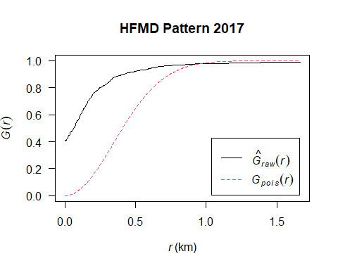

plot(g_pattern_2018, main = "HFMD Pattern 2018", las = 1)

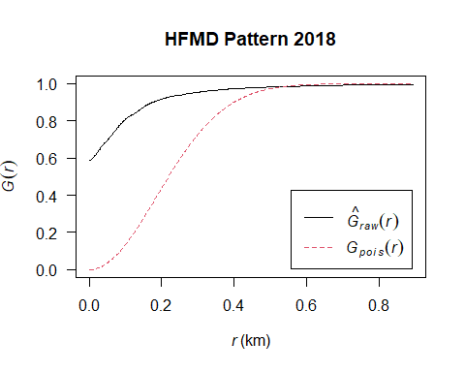

plot(g_pattern_2019, main = "HFMD Pattern 2019", las = 1)

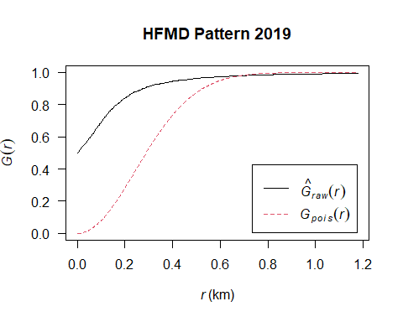

plot(g_pattern_2020, main = "HFMD Pattern 2020", las = 1)

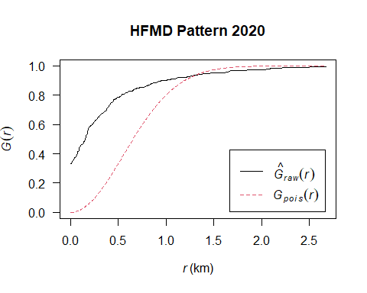

plot(g_pattern_2021, main = "HFMD Pattern 2021", las = 1)

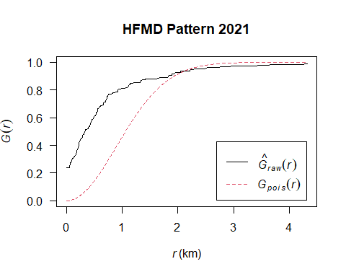

plot(g_pattern_2022, main = "HFMD Pattern 2022", las = 1)

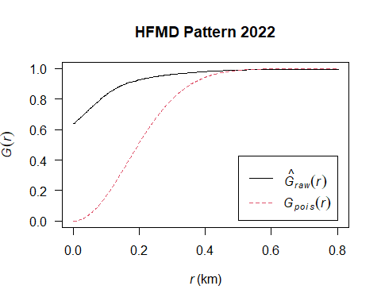

# Generate 99 simulated point patterns under CSR and compute Gest for each  
sim_gest_17 <- envelope(Y2017_coor.ppp, Gest, nsim = 99, correction = "none")

## Generating 99 simulations of CSR ...  
## 1, 2, 3, 4, 5, 6, 7, 8, 9, 10, 11, 12, 13, 14, 15, 16, 17, 18, 19, 20, 21, 22, 23, 24, 25, 26, 27, 28, 29, 30, 31, 32, 33, 34, 35, 36, 37, 38, 39, 40,  
## 41, 42, 43, 44, 45, 46, 47, 48, 49, 50, 51, 52, 53, 54, 55, 56, 57, 58, 59, 60, 61, 62, 63, 64, 65, 66, 67, 68, 69, 70, 71, 72, 73, 74, 75, 76, 77, 78, 79, 80,  
## 81, 82, 83, 84, 85, 86, 87, 88, 89, 90, 91, 92, 93, 94, 95, 96, 97, 98, 99.  
##   
## Done.

sim_gest_18 <- envelope(Y2018_coor.ppp, Gest, nsim = 99, correction = "none")

## Generating 99 simulations of CSR ...  
## 1, 2, 3, 4, 5, 6, 7, 8, 9, 10, 11, 12, 13, 14, 15, 16, 17, 18, 19, 20, 21, 22, 23, 24, 25, 26, 27, 28, 29, 30, 31, 32, 33, 34, 35, 36, 37, 38, 39, 40,  
## 41, 42, 43, 44, 45, 46, 47, 48, 49, 50, 51, 52, 53, 54, 55, 56, 57, 58, 59, 60, 61, 62, 63, 64, 65, 66, 67, 68, 69, 70, 71, 72, 73, 74, 75, 76, 77, 78, 79, 80,  
## 81, 82, 83, 84, 85, 86, 87, 88, 89, 90, 91, 92, 93, 94, 95, 96, 97, 98, 99.  
##   
## Done.

sim_gest_19 <- envelope(Y2019_coor.ppp, Gest, nsim = 99, correction = "none")

## Generating 99 simulations of CSR ...  
## 1, 2, 3, 4, 5, 6, 7, 8, 9, 10, 11, 12, 13, 14, 15, 16, 17, 18, 19, 20, 21, 22, 23, 24, 25, 26, 27, 28, 29, 30, 31, 32, 33, 34, 35, 36, 37, 38, 39, 40,  
## 41, 42, 43, 44, 45, 46, 47, 48, 49, 50, 51, 52, 53, 54, 55, 56, 57, 58, 59, 60, 61, 62, 63, 64, 65, 66, 67, 68, 69, 70, 71, 72, 73, 74, 75, 76, 77, 78, 79, 80,  
## 81, 82, 83, 84, 85, 86, 87, 88, 89, 90, 91, 92, 93, 94, 95, 96, 97, 98, 99.  
##   
## Done.

sim_gest_20 <- envelope(Y2020_coor.ppp, Gest, nsim = 99, correction = "none")

## Generating 99 simulations of CSR ...  
## 1, 2, 3, 4, 5, 6, 7, 8, 9, 10, 11, 12, 13, 14, 15, 16, 17, 18, 19, 20, 21, 22, 23, 24, 25, 26, 27, 28, 29, 30, 31, 32, 33, 34, 35, 36, 37, 38, 39, 40,  
## 41, 42, 43, 44, 45, 46, 47, 48, 49, 50, 51, 52, 53, 54, 55, 56, 57, 58, 59, 60, 61, 62, 63, 64, 65, 66, 67, 68, 69, 70, 71, 72, 73, 74, 75, 76, 77, 78, 79, 80,  
## 81, 82, 83, 84, 85, 86, 87, 88, 89, 90, 91, 92, 93, 94, 95, 96, 97, 98, 99.  
##   
## Done.

sim_gest_21 <- envelope(Y2021_coor.ppp, Gest, nsim = 99, correction = "none")

## Generating 99 simulations of CSR ...  
## 1, 2, 3, 4, 5, 6, 7, 8, 9, 10, 11, 12, 13, 14, 15, 16, 17, 18, 19, 20, 21, 22, 23, 24, 25, 26, 27, 28, 29, 30, 31, 32, 33, 34, 35, 36, 37, 38, 39, 40,  
## 41, 42, 43, 44, 45, 46, 47, 48, 49, 50, 51, 52, 53, 54, 55, 56, 57, 58, 59, 60, 61, 62, 63, 64, 65, 66, 67, 68, 69, 70, 71, 72, 73, 74, 75, 76, 77, 78, 79, 80,  
## 81, 82, 83, 84, 85, 86, 87, 88, 89, 90, 91, 92, 93, 94, 95, 96, 97, 98, 99.  
##   
## Done.

sim_gest_22 <- envelope(Y2022_coor.ppp, Gest, nsim = 99, correction = "none")

## Generating 99 simulations of CSR ...  
## 1, 2, 3, 4, 5, 6, 7, 8, 9, 10, 11, 12, 13, 14, 15, 16, 17, 18, 19, 20, 21, 22, 23, 24, 25, 26, 27, 28, 29, 30, 31, 32, 33, 34, 35, 36, 37, 38, 39, 40,  
## 41, 42, 43, 44, 45, 46, 47, 48, 49, 50, 51, 52, 53, 54, 55, 56, 57, 58, 59, 60, 61, 62, 63, 64, 65, 66, 67, 68, 69, 70, 71, 72, 73, 74, 75, 76, 77, 78, 79, 80,  
## 81, 82, 83, 84, 85, 86, 87, 88, 89, 90, 91, 92, 93, 94, 95, 96, 97, 98, 99.  
##   
## Done.

# Plot observed Gest value with envelope  
plot(sim_gest_17, main = "HFMD Pattern 2017",xlab = "Distance (KM)",  
 ylab = "Proportion of HFMD Cases", cex.axis = 1, cex.lab = 1)

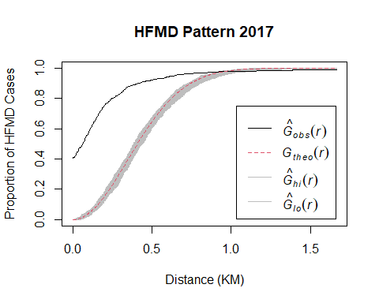

plot(sim_gest_18, main = "HFMD Pattern 2018",xlab = "Distance (KM)",  
 ylab = "Proportion of HFMD Cases", cex.axis = 1, cex.lab = 1)

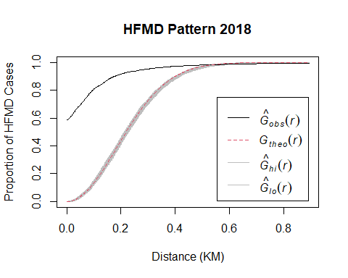

plot(sim_gest_19, main = "HFMD Pattern 2019",xlab = "Distance (KM)",  
 ylab = "Proportion of HFMD Cases", cex.axis = 1, cex.lab = 1)

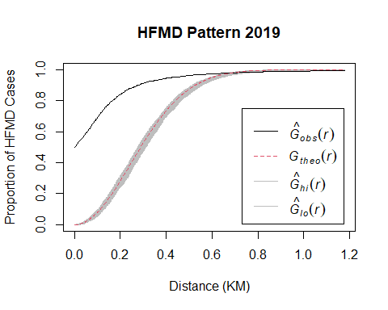

plot(sim_gest_20, main = "HFMD Pattern 2020",xlab = "Distance (KM)",  
 ylab = "Proportion of HFMD Cases", cex.axis = 1, cex.lab = 1)

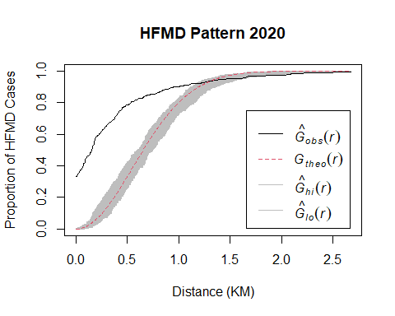

plot(sim_gest_21, main = "HFMD Pattern 2021",xlab = "Distance (KM)",  
 ylab = "Proportion of HFMD Cases", cex.axis = 1, cex.lab = 1)

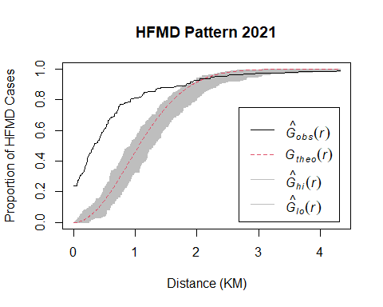

plot(sim_gest_22, main = "HFMD Pattern 2022",xlab = "Distance (KM)",  
 ylab = "Proportion of HFMD Cases", cex.axis = 1, cex.lab = 1)

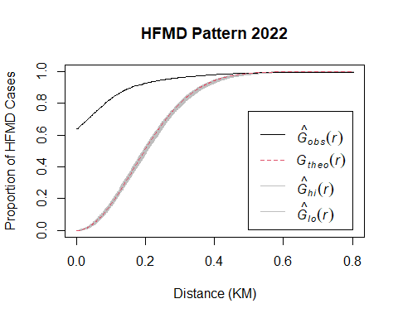

library(gtsummary)

## Warning: package 'gtsummary' was built under R version 4.2.3

##   
## Attaching package: 'gtsummary'

## The following object is masked from 'package:raster':  
##   
## select

library(tidyverse)

Descr_Overal <- read_excel( here("Density Based Analysis",  
 "tbl_data_HFMD.xlsx")) %>%  
 select(YEAR,AGE,age_group,GENDER,RACE,DISTRICT)

tbl_summary(Descr_Overal,  
 by = YEAR,  
 label = list(AGE~ "Age", age_group ~ "Age Group"),  
statistic = c(all_categorical() ~ "{n} ({p}%)",  
 all_continuous() ~ "{mean} ({sd})"))%>%  
 bold_labels() %>%   
 italicize_levels()%>%   
 add_overall()

| **Characteristic** | **Overall**, N = 15,586 | **2017**, n = 1,378 | **2018**, n = 4,793 | **2019**, n = 2,752 | **2020**, n = 534 | **2021**, n = 205 | **2022**, n = 5,924 |
| --- | --- | --- | --- | --- | --- | --- | --- |
| **Age** | 3.53 (3.68) | 3.11 (2.51) | 3.42 (2.74) | 3.15 (2.43) | 2.93 (2.56) | 2.24 (1.69) | 4.00 (4.93) |
| **Age Group** |  |  |  |  |  |  |  |
| *>10* | 453 (2.9%) | 24 (1.7%) | 137 (2.9%) | 48 (1.7%) | 10 (1.9%) | 2 (1.0%) | 232 (3.9%) |
| *0-4* | 12,946 (83%) | 1,202 (87%) | 3,930 (82%) | 2,379 (86%) | 464 (87%) | 197 (96%) | 4,774 (81%) |
| *5-10* | 2,187 (14%) | 152 (11%) | 726 (15%) | 325 (12%) | 60 (11%) | 6 (2.9%) | 918 (15%) |
| **GENDER** |  |  |  |  |  |  |  |
| *Female* | 7,093 (46%) | 612 (44%) | 2,184 (46%) | 1,269 (46%) | 243 (46%) | 86 (42%) | 2,699 (46%) |
| *Male* | 8,493 (54%) | 766 (56%) | 2,609 (54%) | 1,483 (54%) | 291 (54%) | 119 (58%) | 3,225 (54%) |
| **RACE** |  |  |  |  |  |  |  |
| *Cina* | 4,582 (29%) | 726 (53%) | 1,710 (36%) | 1,223 (44%) | 134 (25%) | 17 (8.3%) | 772 (13%) |
| *India* | 664 (4.3%) | 96 (7.0%) | 228 (4.8%) | 134 (4.9%) | 22 (4.1%) | 2 (1.0%) | 182 (3.1%) |
| *Melayu* | 10,160 (65%) | 542 (39%) | 2,768 (58%) | 1,365 (50%) | 375 (70%) | 186 (91%) | 4,924 (83%) |
| *Non-Malaysian* | 105 (0.7%) | 9 (0.7%) | 54 (1.1%) | 11 (0.4%) | 1 (0.2%) | 0 (0%) | 30 (0.5%) |
| *Others* | 75 (0.5%) | 5 (0.4%) | 33 (0.7%) | 19 (0.7%) | 2 (0.4%) | 0 (0%) | 16 (0.3%) |
| **DISTRICT** |  |  |  |  |  |  |  |
| *Barat Daya* | 3,389 (22%) | 177 (13%) | 1,074 (22%) | 621 (23%) | 115 (22%) | 63 (31%) | 1,339 (23%) |
| *S.Perai Selatan* | 2,198 (14%) | 219 (16%) | 780 (16%) | 345 (13%) | 49 (9.2%) | 21 (10%) | 784 (13%) |
| *S.Perai Tengah* | 2,737 (18%) | 214 (16%) | 710 (15%) | 374 (14%) | 123 (23%) | 63 (31%) | 1,253 (21%) |
| *S.Perai Utara* | 2,042 (13%) | 58 (4.2%) | 353 (7.4%) | 368 (13%) | 84 (16%) | 14 (6.8%) | 1,165 (20%) |
| *Timur Laut* | 5,220 (33%) | 710 (52%) | 1,876 (39%) | 1,044 (38%) | 163 (31%) | 44 (21%) | 1,383 (23%) |

#calculate NNI  
library(spatialEco)

## Warning: package 'spatialEco' was built under R version 4.2.3

##   
## Attaching package: 'spatialEco'

## The following object is masked from 'package:raster':  
##   
## shift

## The following objects are masked from 'package:spatstat.geom':  
##   
## is.empty, quadrats, shift

## The following object is masked from 'package:spatstat.data':  
##   
## ants

## The following object is masked from 'package:dplyr':  
##   
## combine

NNI_17 <- nni(Y2017_coor, win = c ("hull", "extent"))

## Warning: data contain duplicated points

NNI_18 <- nni(Y2018_coor, win = c ("hull", "extent"))

## Warning: data contain duplicated points

NNI_19 <- nni(Y2019_coor, win = c ("hull", "extent"))

## Warning: data contain duplicated points

NNI_20 <- nni(Y2020_coor, win = c ("hull", "extent"))

## Warning: data contain duplicated points

NNI_21 <- nni(Y2021_coor, win = c ("hull", "extent"))

## Warning: data contain duplicated points

NNI_22 <- nni(Y2022_coor, win = c ("hull", "extent"))

## Warning: data contain duplicated points

combined_NNI <- bind_rows(NNI_17,NNI_18,NNI_19,NNI_20,NNI_21,NNI_22)  
print(combined_NNI)

## # A tibble: 6 × 5  
## NNI z.score p expected.mean.distance observed.mean.distance  
## <dbl> <dbl> <dbl> <dbl> <dbl>  
## 1 0.325 -48.0 0 504. 163.   
## 2 0.227 -102. 0 280. 63.5  
## 3 0.270 -73.3 0 368. 99.2  
## 4 0.432 -25.1 2.21e-139 794. 343.   
## 5 0.518 -13.2 9.25e- 40 1225. 635.   
## 6 0.201 -118. 0 252. 50.6